=

Public holiday Guide
  - Medical SPECIALISTS
victorian hospital's industrial association – Feb 2024

introduction
The purpose of this Public Holiday Guide is to replace the previous Public Holiday Matrices and summarise the public holiday entitlements afforded to employees under the Medical Specialists (Victorian Public Health Sector) (AMA Victoria/ASMOF) (Single Interest Employers) Enterprise Agreement 2022 – 2026 (Agreement) for the remaining life of the Agreement until it is replaced.
Members will no longer receive multiple Public Holiday Matrices throughout the year, rather members can use this document to prepare for all public holidays for the remaining life of the Agreement.
VHIA has detailed the known public holidays that occur between the publication date of this Public Holiday and the nominal expiry date of the Agreement, 28 February 2026. VHIA will provide updated advice to members closer to that date where the Agreement is anticipated to operate beyond the nominal expiry date.
It is not intended to replace the Agreement or provide an entitlement beyond the Agreement itself.
VHIA encourages members to read the relevant terms of the Agreement alongside this Public Holiday Matrix.

where to find copies of the agreement and other material
VHIA members can access copies of the Agreement and other material (such as Implementation Guides and Salary Circulars) by selecting Medical Specialists under ‘My Professions’ on your VHIA Website Dashboard.
For more information about accessing the VHIA Website, please contact vhia@vhia.com.au

WHO TO CONTACT FOR MORE INFORMATION
Members are encouraged to direct any queries in relation to this Public Holiday Guide to query@vhia.com.au

working on a public holiday
Relevant Clause
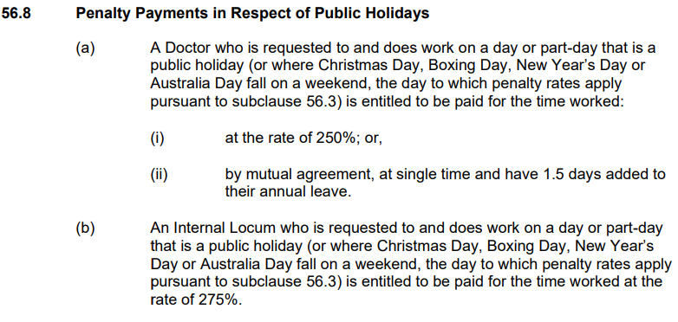

not working on a public holiday – FULL TIME
Relevant Clause
Note: The definition of Actual Day and Other Day can be found summarised below under Additional Rules – Public Holidays falling on a Weekend
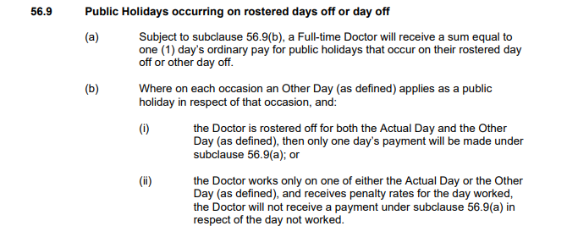

not working on a public holiday – Fractional doctors
Fractional doctors who are not ordinarily required to work on the day on which a public holiday is observed will not be entitled to payment for such public holiday unless they are required to work on that day.

additional rules – public holidays falling on weekend
Note: The only public holiday where this occurs for the remaining life of the Agreement is Australia Day 2025
Relevant Clause
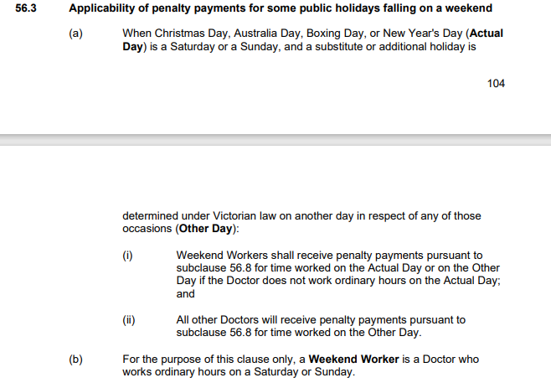

additional rules – other leave on public holidays
Leave Type | Impact of taking leave on a Public Holiday
Annual Leave | If a public holiday falls within a period of annual leave, then extra time equivalent to the public holiday is added to the Doctor's annual leave – see sub-clause 47.5
Personal Leave | If the period during which a Doctor takes paid personal/carer's leave or additional paid sick leave pursuant to subclause 49.1(c) includes a day or part-day that is a public holiday in the place where the Doctor is based for work purposes, the Doctor is taken not to be on paid personal/carer's leave or additional paid sick leave pursuant to subclause 49.1(c) on that public holiday– see subclause 49.5
Long Service Leave | Long service leave is inclusive of (not additional to) Public Holidays that occur during the relevant period of leave - see subclause 55.6
Paid Parental Leave | An Employee on Paid Parental Leave when a public holiday occurs does not receive a public holiday entitlement, nor does it extend the Paid Parental Leave period
Unpaid Leave | If an employee is on Unpaid Leave when a Public Holiday occurs, the employee does not receive a public holiday entitlement.

additional rules – recall on public holiday (Full-time doctors only)
Relevant Clause
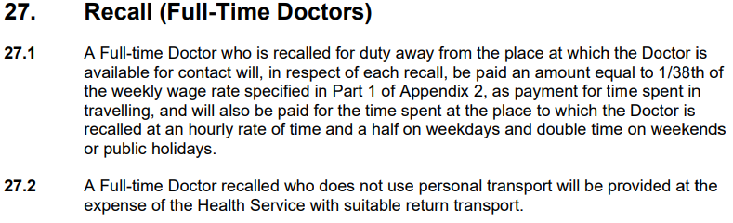

Table 1: Summary of Public Holiday Entitlements

Full Time | Entitlement | Clause Ref.
Rostered to Work (works on public holiday) | 250% or 100% + 1.5 days added to A/L balance | 56.8 (a)
Rostered to Work (not required to work) | 1 days ordinary pay at the rostered hours for that day | 56.1
Not Rostered to Work (rostered day off or other day off) | Weekdays & Weekend PH (incl. Easter Saturday)  1 days ordinary pay (7.6 hours unless the Doctor ordinarily works longer shifts) | 56.9

Fractional | Entitlement | Clause Ref.
Rostered to Work (works on public holiday) | 250% or 100% + 1.5 days added to A/L balance | 56.8
Rostered to Work (not required to work) | 1 days ordinary pay at the rostered hours for that day | 56.1
Not Rostered to Work (rostered day off or other day off) | No rostered off benefit unless they are required to work on that day | Silent

Internal Locum (Casual) | Entitlement | Clause Ref.
Rostered to Work | 275% | 56.8(b)
Not Rostered to Work | No rostered off benefit unless they are required to work on that day | Silent

Table 2: public holidays occuring until nominal expiry date
Note: Public Holidays falling on a weekend are marked in bold
2024
New Years Day – 1 January 2024 | Australia Day – 26 January 2024
Labour Day – 11 March 2024 | Good Friday – 29 March 2024
Saturday before Easter Saturday – 30 March 2024 | Easter Sunday – 31 March 2024
Easter Monday -1 April 2024 | ANZAC Day – 25 April 2024
King’s Birthday – 10 June 2024 | Friday before AFL Grand Final – 27 September 2024
Melbourne Cup – 5 November 2024 | Christmas Day – 25 December 2024
Boxing Day – 26 December 2024
Source - Victorian public holidays 2024 | Business Victoria
2025
New Years Day – 1 January 2025 | Australia Day – 26 January 2025 (A) & 27 January 2025 (O)
Labour Day – 10 March 2025 | Good Friday – 18 April 2025
Saturday before Easter Saturday – 19 April 2025 | Easter Sunday – 20 April 2025
Easter Monday – 21 April 2025 | ANZAC Day – 25 April 2025
King’s Birthday – 9 June 2025 | Friday before AFL Grand Final – TBC
Melbourne Cup – 4 November 2025 | Christmas Day – 25 December 2025
Boxing Day – 26 December 2025
Source: Victorian public holidays 2025 | Business Victoria

2026
New Years Day – 1 January 2026 | Australia Day – 27 January 2026
Labour Day – 9 March 2026 | Good Friday – 3 April 2026
Saturday before Easter Saturday – 4 April 2026 | Easter Sunday – 5 April 2026
Easter Monday - 6 April 2026 | ANZAC Day – 25 April 2026

Melbourne Cup Day is a public holiday across all of Victoria unless alternate local holiday has been arranged by a non-metro council.
ANZAC Day is commemorated on the day it falls. There is no replacement holiday when ANZAC Day falls on a weekend.

