=

Public holiday Guide
  - Allied health professionals
victorian hospital's industrial association – FEB 2024

introduction
The purpose of this Public Holiday Guide is to replace the previous Public Holiday Matrices and summarise the public holiday entitlements afforded to employees under the Allied Health Professionals (Victorian Public Health Sector) (Single Interest Employers) Enterprise Agreement 2022 – 2026 (Agreement) for the remaining life of the Agreement until it is replaced.
Members will no longer receive multiple Public Holiday Matrices throughout the year, rather members can use this document to prepare for all public holidays for the remaining life of the Agreement.
VHIA has detailed the known public holidays that occur between the publication date of this Public Holiday and the nominal expiry date of the Agreement, 28 February 2026. VHIA will provide updated advice to members closer to that date where the Agreement is anticipated to operate beyond the nominal expiry date.
It is not intended to replace the Agreement or provide an entitlement beyond the Agreement itself.
VHIA encourages members to read the relevant terms of the Agreement alongside this Public Holiday Matrix.

where to find copies of the agreement and other material
VHIA members can access copies of the Agreement and other material (such as Implementation Guides and Salary Circulars) by selecting Allied Health Professionals under ‘My Professions’ on your VHIA Website Dashboard.
For more information about accessing the VHIA Website, please contact vhia@vhia.com.au

WHO TO CONTACT FOR MORE INFORMATION
Members are encouraged to direct any queries in relation to this Public Holiday Guide to query@vhia.com.au

working on a public holiday
Relevant Clause

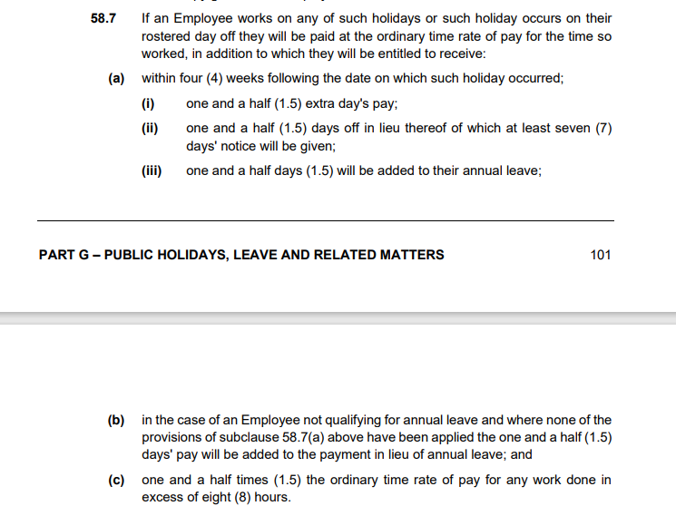

not working on a public holiday – FULL TIME
Relevant Clause
Note: The definition of Actual Day and Other Day can be found summarised below under Additional Rules – Public Holidays falling on a Weekend

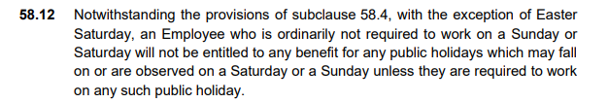
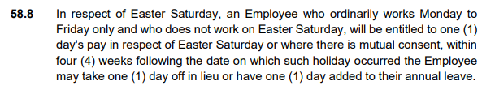

Sub-clause 58.2 (c)
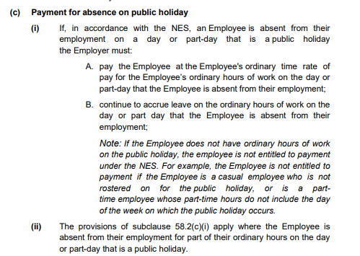

not working on a public holiday – Part TIME

Included with full time clause.

additional rules – public holidays falling on weekend
Relevant Clause

additional rules – other leave on public holidays
Leave Type | Impact of taking leave on a Public Holiday
Annual Leave | If an Employee takes paid annual leave during a period that includes a public holiday, the Employee is taken not to be on paid annual leave on that day and annual leave will not be deducted from an Employee’s accrual for that day– see sub-clause 59.8
Personal Leave | If the period during which an Employee takes paid personal leave includes a day or part-day that is a public holiday in the place where the Employee is based for work purposes, the Employee is taken not to be on paid personal leave on that public holiday– see sub-clause 62.6
Long Service Leave | Long service leave is inclusive of any public holiday or ADO occurring during the period when leave is taken- see sub-clause 72.8
Paid Parental Leave | An Employee on Paid Parental Leave when a public holiday occurs does not receive a public holiday entitlement, nor does it extend the Paid Parental Leave period
Unpaid Leave | If an employee is on Unpaid Leave when a Public Holiday occurs, the employee does not receive a public holiday entitlement.

Table 1: Summary of Public Holiday Entitlements

Full Time | Entitlement | Clause Ref.
Rostered to Work (works on public holiday) | 250% or 100% + 1.5 days added to A/L balance or 1.5 day off in lieu | 58.7
Rostered to Work (not required to work) | 1 days ordinary pay at the rostered hours for that day | 58.2
Not Rostered to Work (rostered day off) | 150% ordinary days pay (using the quantum of hours that the employee usually works in a day) or, 1.5 days added to A/L balance or 1.5 day off in lieu  Weekend PH (excl. Easter Saturday) (e.g. Easter Sunday):  Employees who are Weekend Workers and are ordinarily required to work on the day that the public holiday falls (the Saturday or the Sunday) receive the Not Rostered to Work benefit set out above (150%)  The entitlement does not extend to workers who may ordinarily work on a Saturday (but not a Sunday) and the Public Holiday falls on the Sunday (and vice-versa).  E.g. Employee ordinarily works Saturdays (but not Sundays), the employee would not be entitled to a rostered off benefit on Easter Sunday.  No rostered off penalty applicable if the employee is ordinarily not required to work on a Sunday or  Saturday.  Weekend Worker means any Employee who  in any one (1) year of employment works a portion of their ordinary hours on a weekend.  Easter Saturday only:  Employees who work Monday to Friday only (must work every day) and don’t work on Easter Saturday are entitled to 1 days ordinary pay, or, with mutual consent, 1 day added to A/L balance or 1 day off in lieu | 58.7  58.12  58.1  58.8

Part Time | Entitlement | Clause Ref.
Rostered to Work (works on public holiday) | 250% or 100% + 1.5 days added to A/L balance or 1.5 day off in lieu | 58.7
Rostered to Work (not required to work) | 1 days ordinary pay at the rostered hours for that day | 58.2
Not Rostered to Work (rostered day off) | No clear entitlement, to be used as a guide only.  Over the preceding 6 months if an employee has worked 50% or more of the days on which a particular Public Holiday falls, the employee shall be entitled to receive the "rostered off" benefit for that Public Holiday (150%)  Weekend PH (excl. Easter Saturday) (e.g. Easter Sunday):  As above  Easter Saturday only:  As above | Silent

Casual | Entitlement | Clause Ref.
Rostered to Work | 275% | 20.4 (c)
Not Rostered to Work | No rostered off benefit unless they are required to work on that day | Silent

Table 2: public holidays occuring until nominal expiry date
Note: Public Holidays falling on a weekend are marked in bold

2024
New Years Day – 1 January 2024 | Australia Day – 26 January 2024
Labour Day – 11 March 2024 | Good Friday – 29 March 2024
Saturday before Easter Saturday – 30 March 2024 | Easter Sunday – 31 March 2024
Easter Monday -1 April 2024 | ANZAC Day – 25 April 2024
King’s Birthday – 10 June 2024 | Friday before AFL Grand Final – 27 September 2024
Melbourne Cup – 5 November 2024 | Christmas Day – 25 December 2024
Boxing Day – 26 December 2024
Source - Victorian public holidays 2024 | Business Victoria

2025
New Years Day – 1 January 2025 | Australia Day – 26 January 2025 (A) & 27 January 2025 (O)
Labour Day – 10 March 2025 | Good Friday – 18 April 2025
Saturday before Easter Saturday – 19 April 2025 | Easter Sunday – 20 April 2025
Easter Monday – 21 April 2025 | ANZAC Day – 25 April 2025
King’s Birthday – 9 June 2025 | Friday before AFL Grand Final – TBC
Melbourne Cup – 4 November 2025 | Christmas Day – 25 December 2025
Boxing Day – 26 December 2025
Source: Victorian public holidays 2025 | Business Victoria

2026
New Years Day – 1 January 2026 | Australia Day – 27 January 2026

Melbourne Cup Day is a public holiday across all of Victoria unless alternate local holiday has been arranged by a non-metro council.

